School of Education
PGCE Secondary: Dance
Dance Subject Knowledge Audit

Read the following statements. Consider and assess your own subject knowledge, training, and practice, and for each statement, identify your strengths and areas of development based on your current experience, knowledge and understanding.
Please use the key (Appendix) to support your understanding of the terminology/categories as stated by the AQA GCSE specification.
Performance
- I feel confident in my training of a range of styles. I can teach Contemporary, Jazz, Ballet, and Commercial phrases through accurate demonstrations. I know how to create a variety of challenge in a phrase, that supports or stretches the physical skills of others.

Strengths
Development

- I feel confident in teaching (theory and practical) the technical skills (Action, Dynamic, Spatial, relationship, timing, rhythmic content, and stylistic accuracy). I understand how to vary and scaffold this knowledge for different age groups e.g. y7/y11. I feel confident identifying, analysing, and evaluating the effect of these skills when watching both professional work and student performances.

Strengths
Development

- I can demonstrate excellent expressive skills that reflect a clear choreographic intent. I can identify specific tasks/actions that would improve these skills in the future. I feel confident identifying, analysing, and evaluating the effect of these skills when watching both professional work and student performances.

Strengths
Development

- I understand the differences between the Mental Skills and Safe Working Practices used during the performance, compared to during the process. I understand the importance in teaching and demonstrating these attributes and practices consistently.

Strengths
Development

Choreography
- I can confidently create phrases in a variety of Styles. I feel confident using Choreographic and Structuring Devices to create full length Choreographies (2 minutes +) that communicate a clear choreographic intent.

Strengths
Development

- I can identify, and understand the significance of, the various parts of the Choreographic Process. I feel confident in explaining the process to another person, using examples.

Strengths
Development

- I feel confident in choosing appropriate and effective Aural Setting, Performance Environment, and features of production for my own Choreographies. I understand how these choices could be both original and/or reflect the critical appreciation of professional works being studied in the student’s curriculum. I can justify either of these choices.

Strengths
Development

Critical Appreciation
- I can write example statements of description, analyses, interpretation, evaluation, and reflection. I can compare defining characteristics of 2 choreographies. I can discuss how aspects of Choreography contribute to the audiences understanding of the work. I can analyse the relationships between choreography, performance, and features of production. I can explain the purpose or significance of different performance environments in which the dance was created and performed.

In the box below, write a short response that demonstrates your understanding of the statement above.
You must refer to a minimum of 2 professional works.

Outline below any gaps in your subject knowledge that you would like to gain experience in (E.g. A particular Choreographer, Company, set work or area of study that you have not had the chance to explore).
Please open the links in the Appendix to the AQA GCSE and A level specifications. Download and read.
Consider the compulsory areas of the two courses when writing your response.

Appendix
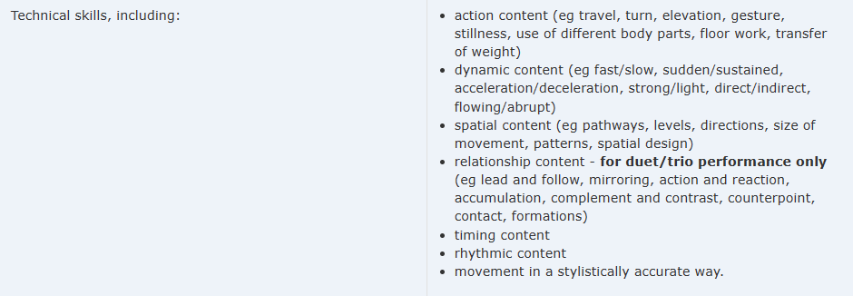
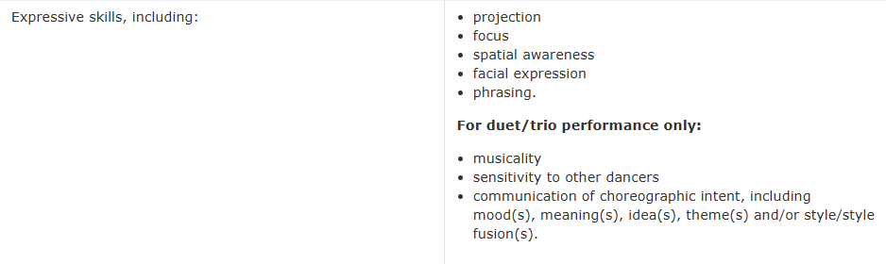
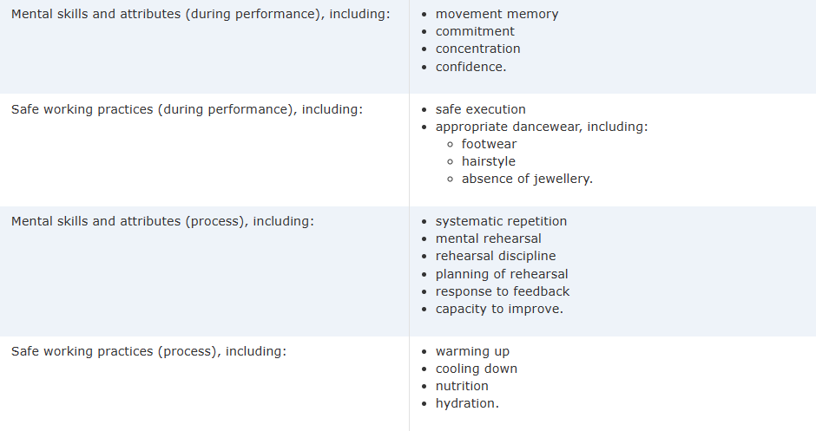
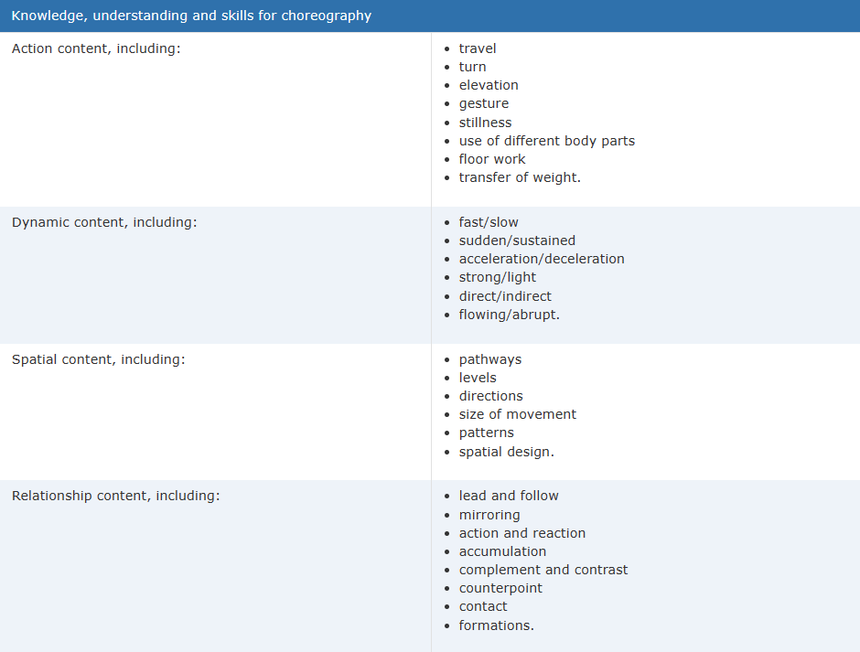
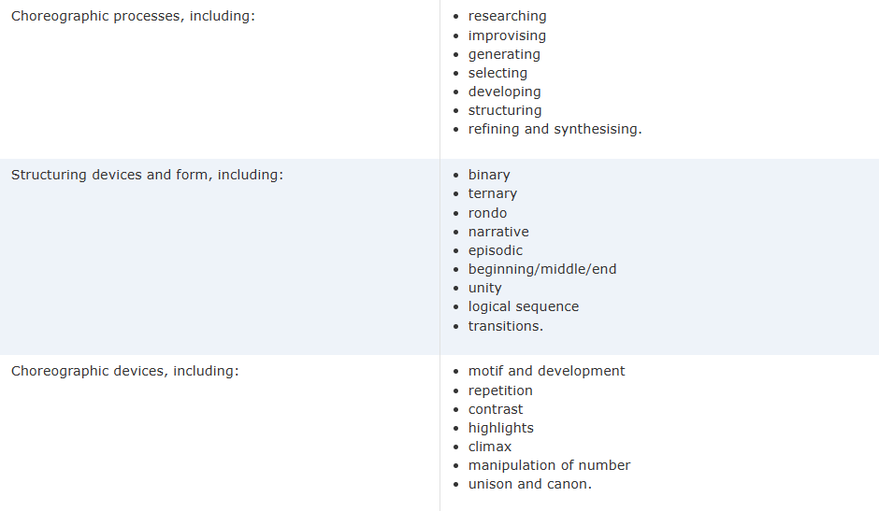
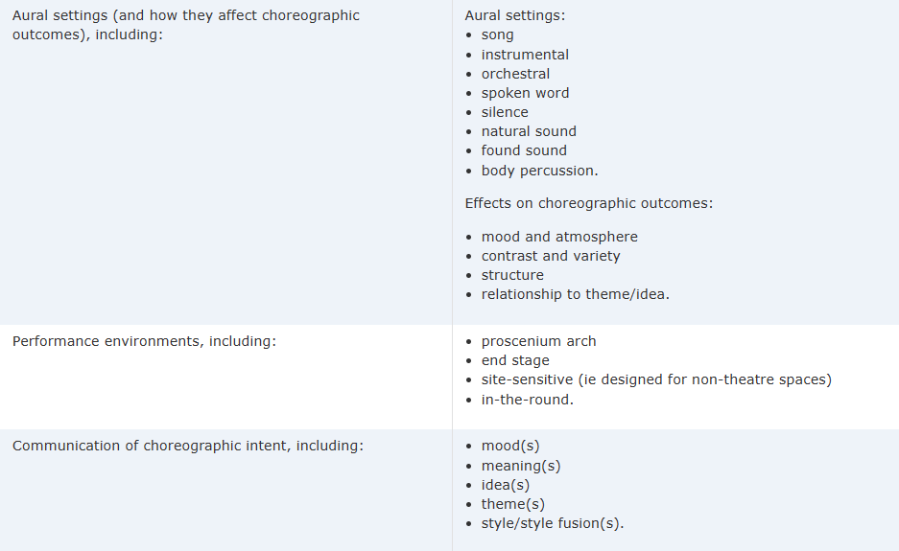
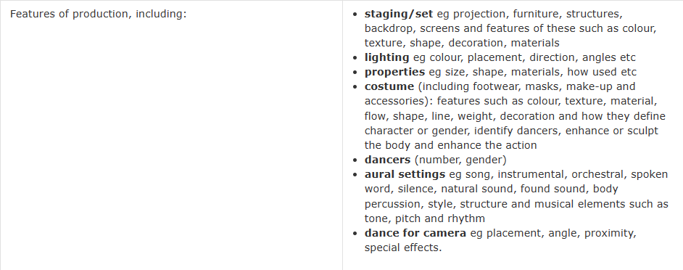

Links:
AQA | GCSE | Dance | Introduction
AQA | A-level | Dance | Specification at a glance

