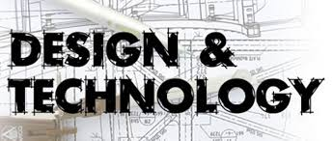

Activities to support the
PGCE Design and Technology Secondary Programme

Part A – Subject Knowledge – use the subject audit from your interview and assess which areas of your knowledge need the most work.

Purchase the GCSE revision booklets for Design and Technology. AQA are pretty good but any of the Exam boards will be fine. (things have changed since you took your GCSE – there is now only GCSE D&T (covers all areas apart from Food) and Food Technology is now Food and Nutrition. (Get Both)
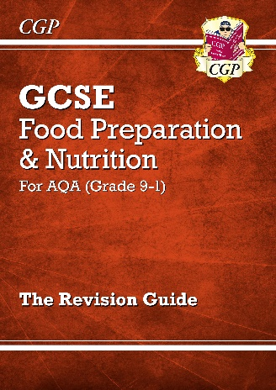
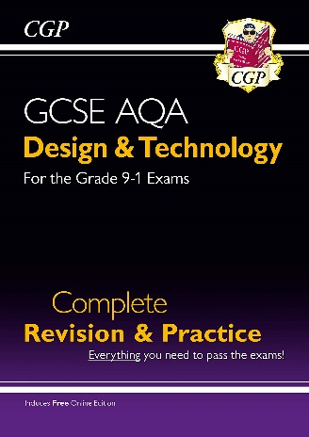

http://www.aqa.org.uk/subjects/design-and-technology
http://www.ocr.org.uk/qualifications/by-subject/design-and-technology/
David Barlex and Torben Steeg – two great D&T Experts have a great website: https://dandtfordandt.wordpress.com/ have a browse but these are good articles to have a look at:

Re-Building D&T, available at: https://dandtfordandt.files.wordpress.com/2017/05/re-building-dt-v21.pdf

Big Ideas for D&T available at:
https://dandtfordandt.files.wordpress.com/2017/05/big-ideas1.pdf

Assessment in D&T available at
https://dandtfordandt.files.wordpress.com/2017/11/wp-assessment-in-dt1.pdf
Dr Alison Hardy - Gain some podcast insights from her website: https://alisonhardy.work/talking-dt/

Try these two first:
https://alisonhardy.work/tdt17/ - What is the point of D&T?
https://alisonhardy.work/tdt10/ - The Intrinsic value of D&T

Have a listen to them and write your top 5 reasons for having D&T in the curriculum. (max 500 words)

Go online to the Design and Technology Association (I would join when you start the course) available at:
https://www.data.org.uk/for-education/secondary/
Have a look at the resources available on the website for Secondary
https://www.data.org.uk/for-education/secondary/
Read the page and download any resources that you think would be good for Understanding the National Curriculum.

Video clips:
Are you really Teaching D&T? (2019) Tony Ryan CEO of DATA - https://www.youtube.com/watch?v=xkaApkVvlSc
This is a great intro – What is D&T
https://www.youtube.com/watch?v=uke5JrrfYxw
Becoming a Secondary Design and Technology Teacher https://www.youtube.com/watch?v=PxMCOl5zozA
D&T: Ownership of learning – observation with John Bayley D&T
http://archive.teachfind.com/ttv/www.teachers.tv/videos/d-t-ownership-of-learning.html

Books:

Pedagogy for Technology Education in Secondary Schools – Research informed perspectives for classroom teachers
Edited by P. John Williams and David Barlex
Published by Springer 2020
See https://www.springer.com/gp/book/9783030415471 individual chapters are available in electronic form from Springer

Food Education and Food Technology in School Curricula - International Perspectives
Edited by M Rutland and Angela Turner
Published by Springer 2019

Learning to teach design and technology in the secondary school (4th edition) edited by Alison Hardy; (see https://alisonhardy.work/teaching-dt/lttdandt/ to be published in Sep 2020

Explorations in Technology Education Research
Helping teachers develop research informed practice
Edited by P. John Williams and David Barlex
Published by Springer 2019
See https://www.springer.com/gp/book/9789811330094

Contemporary Research in Technology Education - Helping teachers develop research informed practice
Edited by P. John Williams and David Barlex
Published by Springer 2017
See https://www.springer.com/gp/book/9789811028175

Critique in Design and Technology Education
Edited by P. John Williams and Kay Stables
Published by Springer 2017
See Critique in Design and Technology Education | P John Williams | Springer

