Secondary Mathematics PGCE
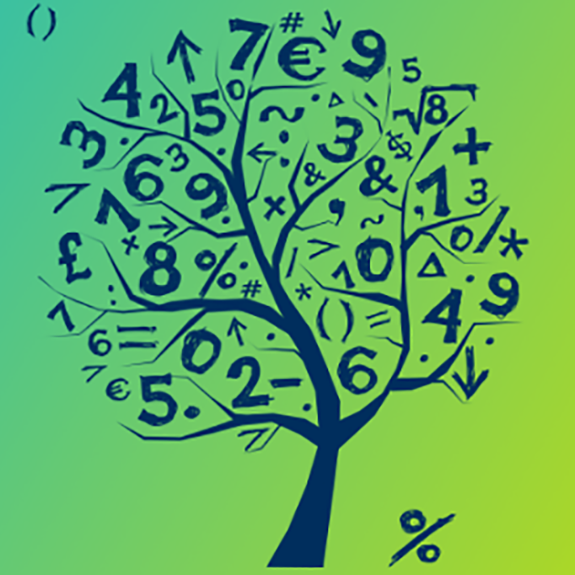
Welcome to the pre-course study before you commence your PGCE Mathematics course at Roehampton.
You will need to begin to form your subject knowledge in both pure and pedagogical terms via your senses.
Subject knowledge
You need to register with the National Centre for the Excellence in Teaching Mathematics NCETM. Registration is for free. At the menu selection at the top of the home page, choose the self-evaluation tools:
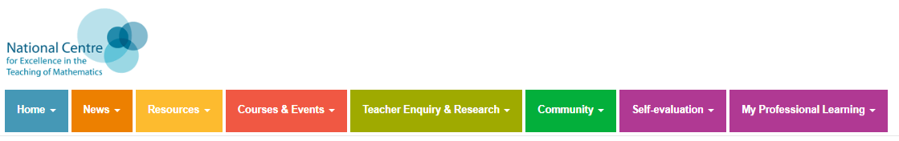
It is here that you will begin your journey of exploring and auditing your pure mathematical knowledge.
Pedagogical subject knowledge
Now that you have begun to develop your pure mathematical knowledge you need to begin to develop your pedagogical senses of the subject.
Sign up on the youcubed website and begin to look at the important work and research of Jo Boaler. When you have signed up you will receive periodic newsletters. Explore the youcubed site to find a wealth of teaching films, Tasks and ideas for you.
Other useful sites for some insights into mathematics teaching:
mrbartonmaths
resourceaholic
NRICH
Watch some mathematics lessons:
Year 7
Year 5
SEN Year 8
You can explore far more on youtube. The important aspect is to ask yourself what are the ‘good, mediocre and bad’ teaching points that you have observed and why do you think this.
Look
Take steps to become aware of the GCSE and A level specifications for the exam boards:
AQA
PearsonEdexcel

Read
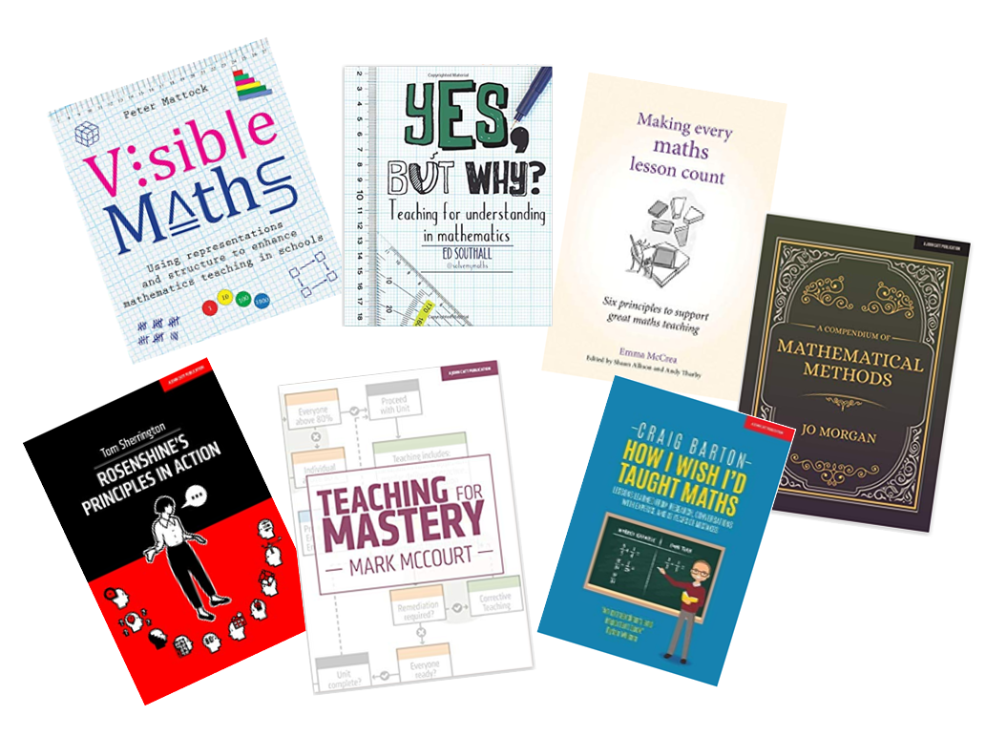
These are some of the essential texts that are used throughout the course and are available in the Roehampton library. Choose one or two for yourself: maybe Craig Barton and Emma McCrea, Jo Morgan.
Look at the research at the National Council of Teachers of Mathematics NCTM. Explore other links from the sites listed above. Overall you are aiming to become familiar with the different avenues of texts which will hopefully begin to influence your thinking.
Sit back and relax
It is the end of August and the course is about to commence.

