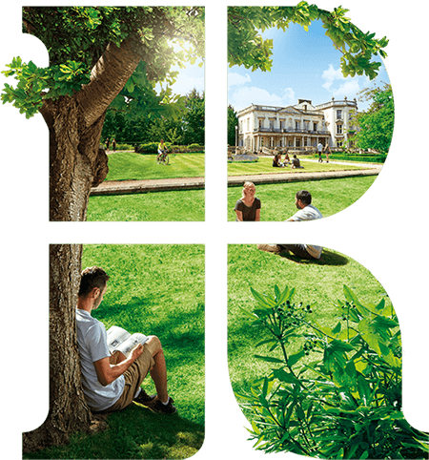

Music PGCE welcome pages
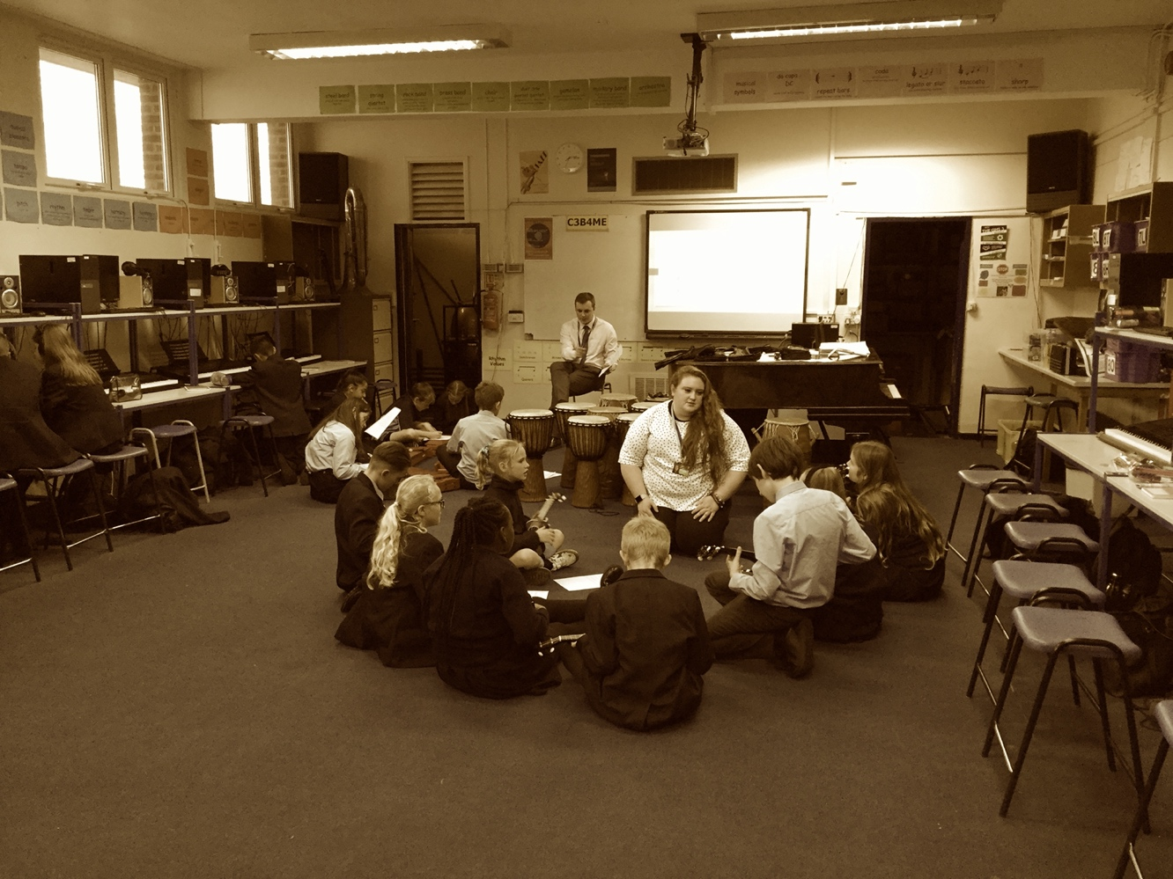
Music Course leader – Kate Potts-Lovegrove

Music PGCE 2020-2021

Welcome to the PCGE Music course! The year ahead will undoubtedly be full of rewards and challenges and we look forward to sharing these with you. The subject studies sessions should add to and develop your existing body of knowledge; helping you to shape this for classroom contexts. Modules we teach have been designed to ensure that you receive both experience in classrooms and seminars which should help you to form a theoretical underpinning to your practice.

To help you prepare for the year, please see the following pages for some suggested reading and activities. Books recommended are readily available to buy and will be in the university library (many as e-books). If you require any further assistance with pre-course reading, please email me: kate.potts-lovegrove@roehampton.ac.uk

Kate Potts-Lovegrove
Subject Studies Lead, Music

Subject Knowledge

Over the year you will be expected to continually update and develop your subject knowledge. To help get started why not:

- Gather copies of pupil textbooks for both KS3 and GCSE Music. Choose a priority study area and read about it in each textbook, making summary notes.

- Test yourself on BBC bitesize website or with questions from Revision Guides, Revision CD-ROMs or GCSE question papers. Check your answers with the Mark Scheme

- Read the National Curriculum 2014 document, identifying key areas of content and concepts which students are expected to study at Key Stage 3

- Follow successful Music teachers on Twitter/Facebook/Instagram, identifying useful activities, resources and strategies which you might apply.

- Visit the websites of the exam boards noted below. Find their existing and incoming GCSE specifications and identify key areas of content and key skills and concepts which they require students to study
www.ocr.org.uk
www.edexcel.com
www.aqa.org.uk
www.wjec.co.uk

- And finally, don’t forget to keep playing, watching, creating music and visiting ‘live’ performances. Watch as much free online music as you can!

Suggested Resources (not a reading list but ways to develop subject knowledge)
This is a list of suggested resources which might prove a useful starting point for the development of your musical understanding. It is by no means exhaustive.

Music History
A History of Western Music by D J Grout
History of western Music – a revision guide – TES
BBC Bitesize for KS3 & KS4
GCSE revision and study guides

Music theory
www.musictheory.net
ABRSM theory guides and practice test papers
The AB guide to music theory – Eric Taylor

Performance
Daily practice – online tutorials for piano, keyboard, guitar, ukulele or bass on YouTube.
Tutors available via Sutton Music Service
Rock and Pop music and graded exemplar material – Trinity board, Guildhall and ABRSM

Composition
Noteflight – free downloadable resources
O-generator
Refer to the set briefs published by the exam board.

Pedagogy

You may wish to familiarise yourself with some music-based pedagogy.

Essential reading - Lesson planning
CORE TEXT - Cooke, C. Evans, K. Philpott, C. Spruce, G (2016). Learning to teach music in the secondary school: a companion to school experience. Abingdon. Routledge. (Third edition)
Evans, J & Philpott, C. (2009) A Practical Guide to Teaching Music in the Secondary School. Abingdon. Routledge.

