SAMPLE: Rubric Managing Organisations Essay 2014 (undergraduate)
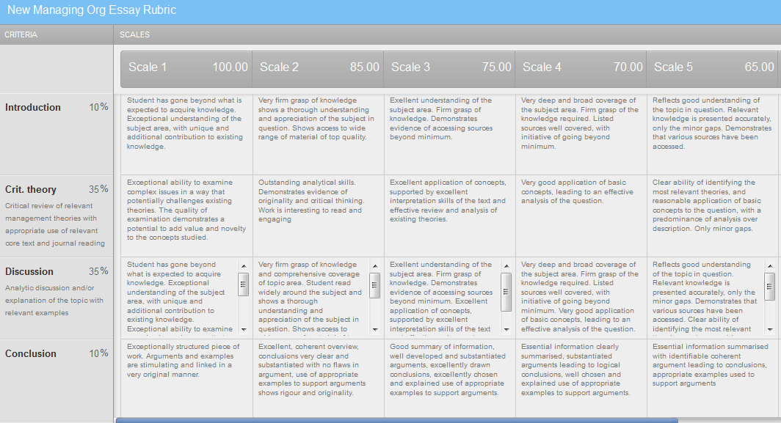

Rubric
