

Important Information
About your Needs Assessment

Access@SW15
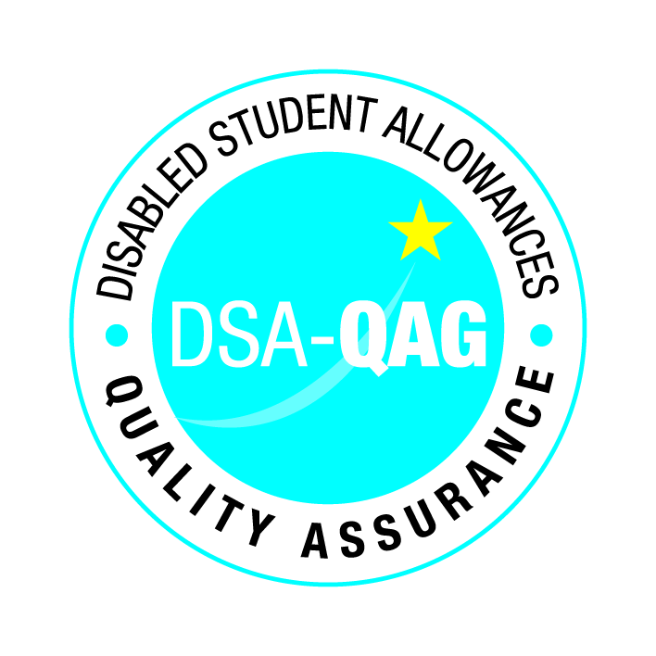
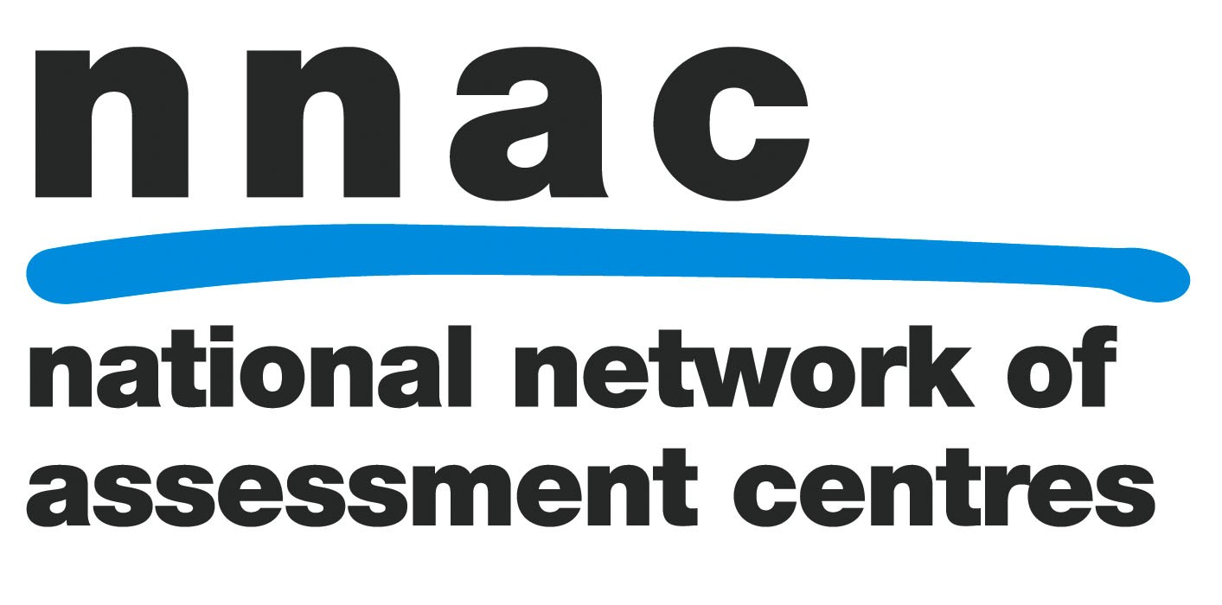

Contents

Contents 1

Introduction 2

I’ve Got My Needs Assessment 3-5
Report, What Do I Do Now?

Accuracy, Errors and Omissions 6

Equipment Supplier – Service
Level Agreement 7- 9
What Happens To My Equipment
When I Have Finished The Course? 10
Posture Advice When
Using A Computer 11-12

How to Contact The
Roehampton Access Centre &
Sources of Further Information 13

Introduction

If you are reading this booklet, it is likely that you have just received a copy of your Needs Assessment from the Access@SW15 Centre. The staff at the centre hope you found the Needs Assessment a pleasant and useful experience.

The purpose of this booklet is to provide you with some additional information about your Needs Assessment Report and to give you some advice on what to do next. We hope it is useful to you.

I’ve Got My Needs Assessment Report, What Do I Do Now?

If you asked for a draft report to be sent to you before copies were sent to your funding body and your University, then you need to read through it carefully. If there are any changes you would like made to the report, you need to get back to us within five working days to let us know about them. Once this is done we’ll send you a final copy of the report and send your report to your funding body and your University.

If you did not ask for a draft report, then the copy we sent you is the final copy. However, if you have any concerns, then do still get in touch with us at the Centre; it’s not too late to make changes.

Once you have the final copy of your report read through it again and if you have any questions or need help to put your support in place, then arrange a meeting with the Disability Advisor at your University/College. They will be happy to go through this report with you and explain what you need to do next.

NB: We will only send a copy of your report to your University if you have given us permission to do so.

Now that I’ve got my report, when will I get some support?
Before you receive any support, you will need to wait for a letter from your funding body confirming that they are willing to pay for the support recommended in your report.

What can I do to make sure I get my support quickly?

- If you haven’t heard from your funding body within three weeks of receiving your report, call them and find out what is going on;

- Arrange an appointment with your Disability Advisor at your University/College to discuss your report;

- Ensure all appropriate staff in the academic departments are aware of the relevant recommendations in your report. Show them the report if you feel comfortable with this;

- Liaise with library staff regarding recommendations within the report (you’ll find these recommendations at the back of your report);

- Once your funding body has approved your Needs Assessment, they will send you a DSA2 letter, telling you what to do next. You should ensure an order is placed with the recommended supplier for the equipment. Your funding body will have told you which supplier to use in the DSA2 letter. You will probably have to place the order for the equipment yourself. Your Disability Advisor can help you with this.

- Obtain and keep a copy of all receipts for equipment, photocopying, computer paper, batteries, etc. You will find what you are entitled to in the General Allowance section of the report. Forward these, with the appropriate claim form to your funding body to reclaim any expenses.

- Organise your AT training, there isn’t much point getting all this great software if you don’t know how to use it. Your funding body will have advised you which supplier to use in their DSA2 letter to you.

Accuracy, Errors and Omissions

Whilst every effort has been made to ensure that all statements and information offered in your report are given in good faith, they relate to matters discussed during the assessment and information supplied by you, university staff and any others consulted, or spoken to during and after the assessment. The items commented on in this report are limited to areas identified at the time of the assessment and subsequent research, and should not be taken as identifying all areas of difficulty that may arise during the course.

If additional areas of difficulty arise, you should contact the Disability Advisor at your institution or the DSA Needs Assessor who assessed you, your Assessor can be contacted via the Access Centre.

We make every effort to ensure that the information we provide is accurate and up to date. We will promptly correct any errors or omissions brought to our attention.

Equipment Suppliers – Service Level Agreement

Students are not always experts in information technology systems and may have no experience of setting up equipment or installing software. It is therefore essential that any equipment and associated software supplied through the Disabled Student’s Allowance is set up by the supplier to ensure that it functions correctly, its future functioning is guaranteed and that the student is able to begin to access the equipment immediately. In order to ensure this is the case suppliers will have signed up to a service level agreement in which it is recommended that all suppliers of equipment be requested to undertake the following:

- Guarantee to supply the full range of equipment and latest versions of software recommended in this report which have been approved by the funding body (including specialist software).

- Take note of the student’s particular needs as outlined by the assessor when meeting with or talking to the student.

- Set up the full system, checking the hardware and software operation to ensure that the system is working correctly.

- Offer to provide orientation to the student and demonstrate start up, shut down and house keeping for the system.

- Supply a warranty for the system, including responsibility for software, for the duration of a student’s course of study (maximum four years).

- Provide a help line during working hours for hardware and operating system issues.

- Provide a warranty that as soon as it appears likely that the computer will be away for more than seven working days, the supplier will provide a loan machine. The supplier will undertake to ensure that the loan machine runs substantially all the software that was initially supplied with the equipment, and install this. The supplier will use reasonable endeavours to recover data from the hard disk of the machine requiring attention.

Your funding body will advise you which equipment supplier to use in the DSA2 letter to you.
If you wish to use an alternative supplier you must discuss this with your funding body first.

You should also be aware that the delivery and initial set up of the equipment, does not include AT training. The provision of this will also have been confirmed within the DSA2 letter.

What Happens To My Equipment When I Have Finished The Course?

Any equipment purchased through the DSA is yours to own and keep once you have completed your course. However, should you leave the course you are advised to inform the funding body of the fact as soon as possible. You may have to give the equipment back.

Once you have finished the course you should not sell or otherwise dispose of the equipment if you expect to continue your studies. Whilst you may be able to apply for a new DSA, any equipment previously provided will be taken into consideration in the new assessment, if your existing equipment is still adequate for your study needs.

Posture advice when using a computer

- Take care to adopt a comfortable and ergonomically correct posture when working at the computer for long periods. The chair and keyboard should be set so that the thighs and forearms are level (or sloping slightly down away from the body), and the wrists are straight and level. It should be possible to sit comfortably and straight without stretching forwards to reach the keys or see the screen.

- Relax and shift positions frequently. This includes stretching and exercise of the shoulders, back and neck. Take regular breaks or at least vary the type of work you are doing every twenty minutes.

- Increase computer font size and colours to make the screen as comfortable as possible to read from (your IT trainer can show you how to do this).

- Use a light touch on the keyboard.

- Use two hands to perform double-key operations like Ctrl-C or Alt-F.

- Place the mouse where you don't have to reach up or over very far to use it; close to the keyboard and edge of the desk is best.

- Focus on a spot in the distance away from the computer monitor every five minutes to prevent eyes from becoming dry and tired.

- Proof read using hard copy rather than on screen.

How do I Contact Access@SW15?

The Access Centre can be contacted at the following address:

Access@SW15
Student Services
Digby Stuart College
Roehampton University
Roehampton Lane
London
SW15 5PU
Tel: 020 8392 3403
E-mail: accesscentre@roehampton.ac.uk

Sources of Further Information

Department for Business, Innovation and Skills. Guide to Disabled Students’ Allowances:
http://www.bis.gov.uk

National Union of Students:
http://www.nusonline.co.uk

