
RESEARCH DEGREE PROGRAMMES APPLICATION GUIDANCE

Doctor of Philosophy (PhD), PhD (Professional) Education, PhD by Published Works, PhD by Portfolio (undergoing validation) and DTh Practical Theology
Applicants must contact a relevant member of academic staff for an informal discussion about their proposed research topic and eligibility. Please search for a potential supervisor via the Research Centres in Academic Schools, detailed on our website, or via the School’s Research Programme Leader (RPL).

https://www.roehampton.ac.uk/graduate-school/degrees/

DTh Practical Theology: DTh applicants are encouraged to contact the DTh Programme Leader in the first instance.

If you need assistance or advice about Schools, please contact the Graduate School using the following email address: pgresearch@roehampton.ac.uk

Eligibility:
You are expected to hold a master's degree in a relevant subject area or in some cases, be able to provide evidence of equivalent experience and learning acquired in a professional context.

If you are applying for a PhD (Professional) Education or PhD by Portfolio: A minimum 2:2 honours degree from a UK university in a relevant subject area, or an equivalent academic qualification, or evidence of equivalent experience and learning acquired in a professional context (it is desirable to have evidence of successful learning at level 7 but not a requirement to have a full Masters);

Completing the Online Application Form

Applicants must have made contact first with the relevant academic School for their application to be considered.

Applications are made through the online portal. Please note that you must complete and upload all supplemental items after you have submitted your application. If we do not receive missing information within two weeks of your initial application, your application will not be progressed. Supplementary material that is uploaded after the application deadline will not be considered. Incomplete applications received after the relevant application deadline will be rejected.

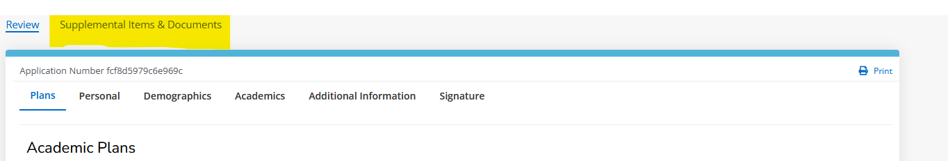
Supplemental material includes degree certificates, degree transcripts, research proposal and references. Supplemental items will be able to be added to your application once you have submitted it.

Please start by selecting your entry term, on the next page you will be asked to provide your intended level of study (‘Research’ in this case).

DTh Practical Theology: Please note that the January start date is not available for this programme.
The following information must be included within the appropriate section of the application form to enable it to be reviewed in the Graduate School and considered by the School:

Section 1: Plans

- Under ‘Level of Study please select ‘Research’

- Under ‘programme’ select the doctoral programme closest to your research, please note that your final certificate would be in this subject area

- Under ‘Start Year’ and ‘Term Intake’ there will be one option to select This option will be the next start year and term that you can apply for. Under start year and term intake to select and then chose whether you wish to study full or part time on your PhD under ‘mode of study’.

- Select whether or not you have previously studied at Roehampton.

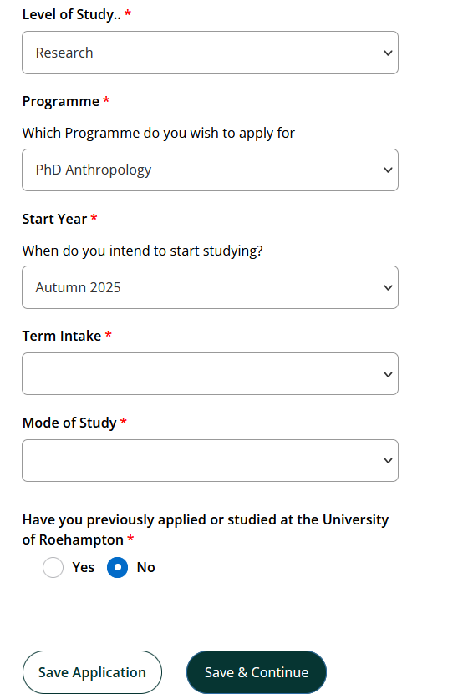

Section 2: Personal Details
- Please complete all the details requested in this section.
- NOTE: The name which you give will be that under which you are registered with the University and will be the name that will appear on your degree certificate. It needs to be your name as detailed on your passport.

- NOTE: The permanent home address will be that retained on your student file and will be used for all correspondence unless you provide an alternative address.

- Please provide details of your residency over the last three years – this will be used to determine your fee status. To quality for Home, a student needs to be ordinarily resident in the UK for three years and their main purpose for that residency must not be for full- time education. Please see the UK Council for International Student Affairs website.

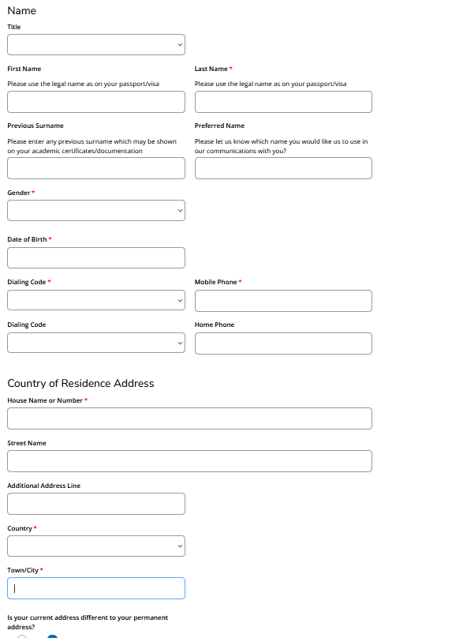

Section 3: Demographics

- Please complete all of the mandatory details requested in this section.

- Please provide details of your residency over the last three years – this will be used to determine your fee status. To quality for Home, a student needs to be ordinarily resident in the UK for three years and their main purpose for that residency must not be for full- time education. Please see the UK Council for International Student Affairs website as well as this link.

- Please enter any disability information that you feel comfortable sharing.

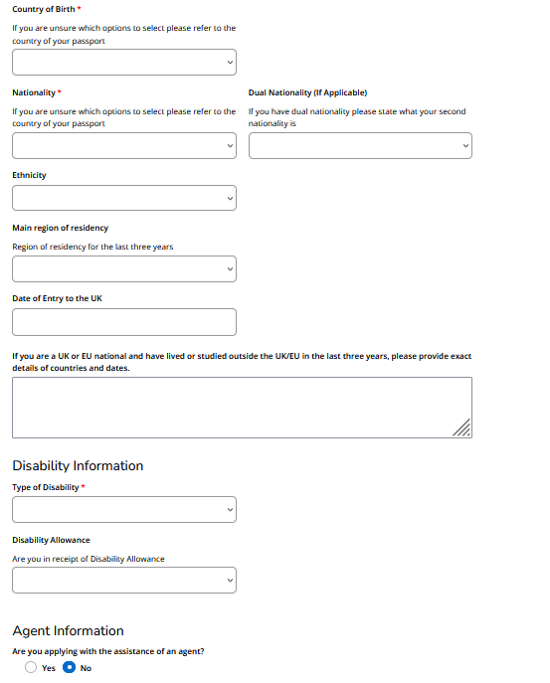

Section 4: Academics
- Please complete all of the mandatory details requested in this section.
- If you are an overseas student then you must answer the question regarding your English language Proficiency.

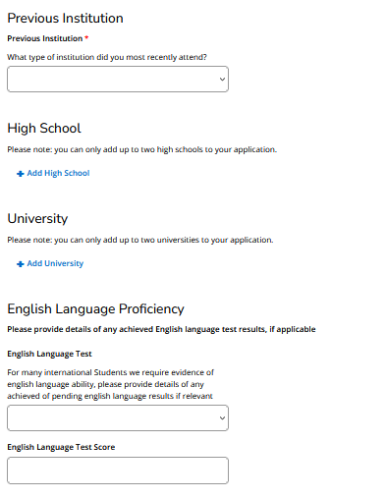

Section 5: Additional Info
- Please complete all the details requested in this section.
- Personal Statement - Please prepare a brief personal statement about your application and why you wish to apply for this programme of study. (More detail on the research proposal and what it expected to be included within it can be found further on in this document under the heading ‘research proposal’.

- Academic contact details – Please write down the name of the academic within the school that you have spoken to. Please note that if you have not spoken to an academic with the university your application may not be considered. If you do not have a name to give here, please contact pgresearch@roehampton.ac.uk for guidance, save your application and wait until you have spoken to an academic before coming back and completing the application.

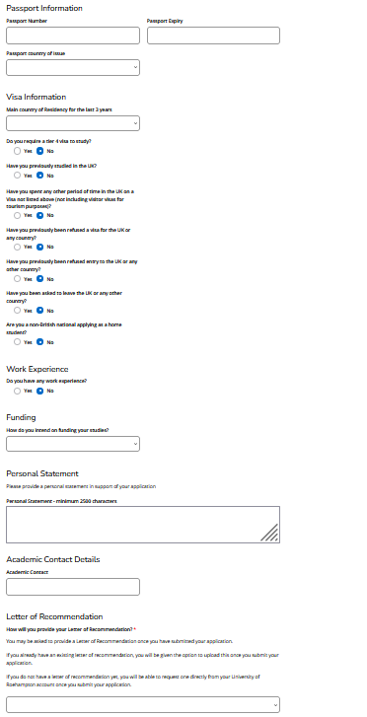

Section 6: Signature
- Please complete all of the sections here.
- Please note that by submitting your application you are agreeing to the terms and conditions set out by the University of Roehampton’s Admissions Policy which can be found here. As part of the application process, you also consent to the University of Roehampton's validation of your entry qualifications.
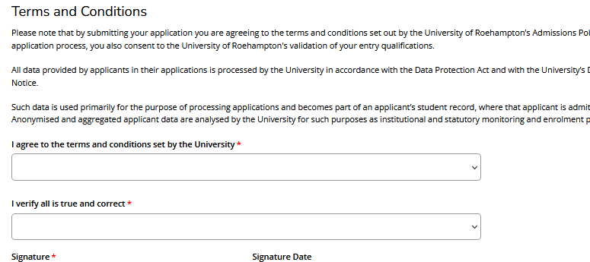
- Please only submit the application if you have named an academic contact on the previous page.

Section 7 after submission: Supplemental Items & Documents

You must submit all the supplemental items for your application to be completed. You will receive reminders from the system if you have not completed this step. Incomplete applications will not be considered.
- My account – Under my account you will see your applications and you will see ‘action required’ underneath ‘status’. Click ‘view’ under ‘action’.
- Supplemental Items – Please complete all sections here and upload the relevant information.

Research proposal
- Please upload a separate document outlining your intended research.
- Please structure your proposal as follows:
  - Title of your research project
  - Scope of the Proposed Research (300-500 words long)
    - a non-technical (lay-person) summary of your proposed research
    - a description of the broad subject area of your project, including its relation to other work in the field
    - the aims and objectives of your proposed research
    - an outline of any hypotheses or research questions which will be addressed
    - a brief, indicative bibliography

  - Research Methodology and Design (300-500 words long)
    - an indication of the proposed methods to be used in the research (including the gathering and analysing and/or interpretation of data/information)
    - the reasons for selecting these methods given your proposed subject area
    - provisional timetable of the work through to the submission of the completed thesis, including, if relevant, the dates and expected length of any fieldwork to be undertaken abroad.
    - Training, Facilities and Resources (300-500 words long).
    - Please indicate any specialist training, including taught research methods programmes, and other resources necessary for the research (e.g., laboratory space, computing facilities, specialist Library access). Please note that all MPhil/PhD students will be required to complete the University’s Research Student Development Programme as part of their research programme.

References

- Please upload a current, relevant reference related to this application. References older than 6 months cannot be accepted.

- Please note that unless you are a recent graduate of Roehampton University, you will be expected to provide at least one external academic referee who will be able to comment upon your academic ability and suitability to undertake the proposed research. These should be supplied by academic staff at university- level institutions where you’ve previously studied. Also note that references from proposed/intended supervisors at the University will not be permitted.

If you are applying for PhD by Published Works:
You should use the Research Proposal section to explain the academic context of your publications and how they can be regarded as a coherent body of work meriting the award of a PhD. You need to provide enough detailed information to ensure that the School can assess the viability of your project. You should provide some samples of your work for review,
and may be asked to provide further examples once your application has been looked at. These could be uploaded as supporting documents. An Application Fee of £572.00 is payable via the University’s Online Store. This covers assessment and review of your submitted publications.
http://estore.roehampton.ac.uk/product-catalogue/graduate-school/phd-by-published-works

If you are applying for DTh Practical Theology:
Please include a statement of how the proposed research contributes/dialogues with professional practice.

- References should be supplied as scanned copies of signed letters on official letterheaded paper and/or sent from an official email address of the organization where the referee works.

- You may be asked to provide a further reference, or your referee may be contacted by the University if further clarification is needed.

If you are applying for a PhD (Professional) Education or PhD by Portfolio, then applicants can provide a professional reference as their second reference in addition to the first academic reference.

If you are applying for the PhD by Portfolio,
You should use the Research Proposal section to provide detail on your professional portfolio of outputs (reports, publications etc.) and how they can be regarded as a coherent body of work meriting the award of a PhD. You need to provide enough detailed information to ensure that the School can assess the viability of your doctoral portfolio.

If you are applying for DTh Practical Theology, please upload two current relevant reference letters. One of these references can be an ‘academic reference’ (i.e. from someone who can comment on your academic ability and suitability to undertake the proposed research). The second reference can be a ‘professional reference’ (i.e. from someone who can comment on your professional practice). Your professional reference should indicate/demonstrate the following:
- That you have an established practice (professional or voluntary)* which is related to your proposed area of research.
- That you demonstrate high levels of good practice in your work
- That have personal qualities which will enable you to organise study alongside your work, and enter into your research in a communally constructive way.

* Research carried out for the DTh focuses on a wide range of faith practices under the umbrella of ‘practical theology’. The practices researched may be part of a student’s paid ‘professional’ work; but is just as likely to be based in their established voluntary work relating to their faith and / to their faith community. In responding to this request for a ‘professional reference’ please interpret this term very broadly to include a range of practices. The description of this reference as ‘professional’ into distinguish it from ‘academic’ references, in keeping with processes for application to professional doctorates more widely.

Once received, your application will be downloaded by the Graduate School and reviewed prior to passing to the academic schools. Should any documents be missing, you will be contacted via email, by the Graduate School. If the outstanding documents are not received within two weeks, your application will be closed.
Please note that if you do not include the name of a member of academic staff with whom you have discussed your proposal, your application will not be processed. Contact us if you need help with this:
pgresearch@roehampton.ac.uk

Thank you and good luck with your application.

