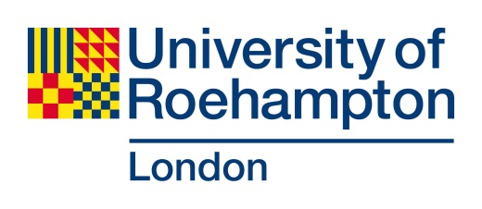

Money matters
Currency
While you are in the UK, you have the choice of using cash, debit card or credit card. Your debit card and credit cards may give the best exchange rates and are generally accepted anywhere, but your bank may charge you a fee for overseas purchases. Please check charges with your bank before coming to the UK. If you plan to use credit cards for purchases in the UK they will need to have been signed on the back and have a chip and pin. Otherwise, you may only be able to use them to take cash out of an ATM. Before you leave, be sure to notify your bank that you’ll be using your cards overseas to prevent them freezing your account when they notice unexpected purchases in London.

It's a good idea to bring about £100 in cash with you. If you’re not using Roehampton’s meet-and-greet service from Heathrow you may need money to pay to get to your accommodation, and you may wish to buy something before you can get to an ATM (known as a cashpoint or cash machine in the UK) or bank.

As in any large city, it is best not to carry large amounts of cash around with you. To see the current conversion rate between your country’s currency and Great British pounds, visit http://www.oanda.com/

Bank accounts
During orientation you will have the opportunity to open a bank account with Santander who has a branch on campus. This is optional and you may decide not to open one, or choose an alternative provider.

If you wish to try to open a bank account you should bring with you:
· Passport
· Letter of enrolment
· Evidence of funding for your studies

Average prices in London

Pint of milk – 50p

Bus journey – £1.50

Seven day travel card for the tube - £37.70

Pint of beer - £3-£4

Movie ticket - £7 - £10

Theatre ticket - £25+

Pub meal - £10-£15

