Undergraduate Programme Annual Review (PAR) Cycle Diagram (Collaborative Partners)

Semester 1

Module Evaluation Survey Data

EE Reports (written)

LTQG Scrutiny of Draft PAR

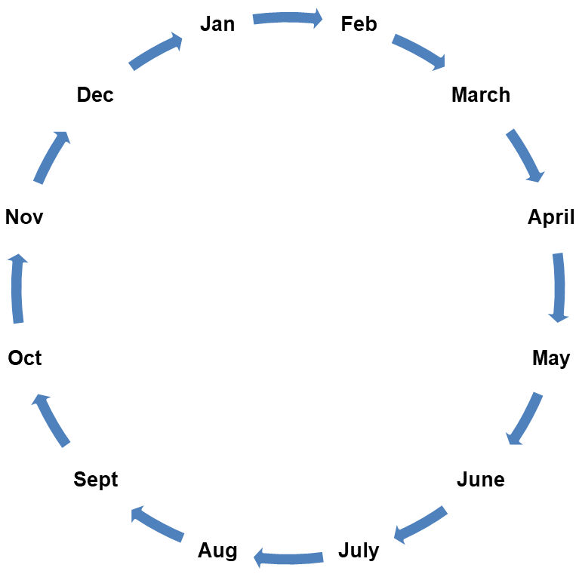

Programme Board

LTQC receives UG PAR Report Summary

Submission of UG PAR Report Summary

Programme Board

Semester 2

Module Evaluation Survey Data

Final Progression and Attainment Data, NSS, Enrolment/Tariff Entry Points

Programme Board

University PAR Panel

**Submission of final PAR report to Academic Office**

Forecast Progression and Attainment Data, DLHE, EE Report (verbal)

PAR Planning Meeting

Programme/Department Meeting

Data Source

University Meeting

Submission Deadline