**Last Updated: April 2018**

**UNDERGRADUATE PROGRAMME ANNUAL REVIEW**

**(Collaborative Partners)**

**Introduction**

1. The Programme Annual Review (PAR) for taught programmes is an important part of the University’s quality assurance processes. The PAR is an evaluation of a programme’s performance over an academic year involving careful reading and evaluation of evidence and identifying areas for improvement based on that evidence. The PAR should be a reflective process for the programme team(s), providing an analysis of past performance and the development and implementation of evidence-based action plans for the future. The evaluation must draw upon programme data and the evidence will include:

* Programme performance data
* Changes to the curriculum
* Module Evaluation Survey
* External Examiner report(s) and response(s)

1. For the University, this process provides assurance that an academic review is taking place, and an opportunity to intervene in programme-specific issues where necessary. Immediate operational issues should be referred to line managers.

**PAR report template**

1. The PAR report comprises four sections:

* Programme summary – to put the report into context, for example, if this is the first year of the programme, whether it has undergone periodic review, whether any innovative practices have been introduced and an assessment of them, strengths and weaknesses.
* Key priorities from the previous academic year – monitoring progress of actions identified in the previous year
* Standards, Quality and Enhancement Plan – highlighting key priorities or issues to address
* Curriculum changes – that have been made in the year under consideration, or in the previous year and their impact during the year under consideration, or changes which are under discussion for the following year.

The LTQG scrutiny report is part of the PAR report and should be completed by the academic department LTQG Chair. If LTQG requires changes to the report, these need to be signed off by the LTQG Chair before the report is submitted to the Academic Office.

1. The Standards, Quality and Enhancement Plan should highlight key issues or areas to be addressed across the programme. By using performance indicators, the plan should address the core university issues around teaching excellence, student satisfaction, retention and graduate progression, including by different student groups.

Completion and approval of PAR report

1. Programme teams should hold a PAR planning meeting following the final Programme Examinations Board of the year. The team will evaluate the current state of the programme using the data provided and the existing Standards, Quality and Enhancement Plan and consider what improvements need to be considered.
2. Collaborative partners should use their own performance data.

These include:

* NSS, if appropriate
* Non-continuation
* Graduate employment and further study
* Module evaluation data
* Distribution of awards
* Module attendance and failure rates

1. The draft PAR report will then go through a scrutiny process at an extraordinary meeting of the LTQG, or subgroup of it. This should take place in early September, but can be before, and the outcomes recorded on the PAR LTQG scrutiny report. This scrutiny process should assess the evaluation of the data and the conclusions being drawn, including highlighting any factual inconsistencies in the document or possible typographical errors. Teams should ensure that, where required, revisions are made to the report and they are signed off by the LTQG Chair on the scrutiny form before it is submitted to the Academic Office. Where there are considerations for the University, these need to be noted in the scrutiny form and approved by LTQG.
2. The final, revised version of the PAR report must be submitted to the Academic Office by mid-September and will be considered by a University UG PAR Panel, chaired by the Deputy Provost: Learning and Teaching, in October. The Link Tutor will be invited along to this meeting in slots allocated by the academic department. A PAR summary report will be produced subsequently which will be submitted to the Learning, Teaching and Quality Committee.
3. Collaborative partners are expected to complete a PAR report for both validated and franchised taught programmes. The Link Tutor is considered to be part of the programme team and should contribute to the writing of the PAR report,but not to its scrutiny. The Collaborative PAR reports will go through the same scrutiny process as internal programmes.
4. Undergraduate PAR Cycle Schedule

|  |  |
| --- | --- |
| February/March | Programme Board (review Semester 1 Module Evaluation Survey data)  Update Standards, Quality and Enhancement Plan |
| April/May | Programme Board (review Semester 2 Module Evaluation Survey data)  Update Standards, Quality and Enhancement Plan |
| June/July | PAR planning meeting (review forecast progression and attainment data, DLHE, External Examiner report (verbal)) |
| July to September | Drafting of PAR report |
| By early September | LTQG scrutiny of draft PAR report |
| By mid-September | Submission of final PAR and scrutiny report (including Annexes) to the Academic Office |
| October | University PAR Panel |
| End-October | Programme Board (review final progression and attainment data, NSS, enrolment/tariff entry points)  Update Standards, Quality and Enhancement Plan |
| Mid-November | LTQC receives PAR summary report |
|  |  |

1. See Annex A for the UG PAR cycle.
2. See Annex B for the UG PAR report template

**Annex A**

**Undergraduate Programme Annual Review (PAR) Cycle Diagram (Collaborative Provision)**

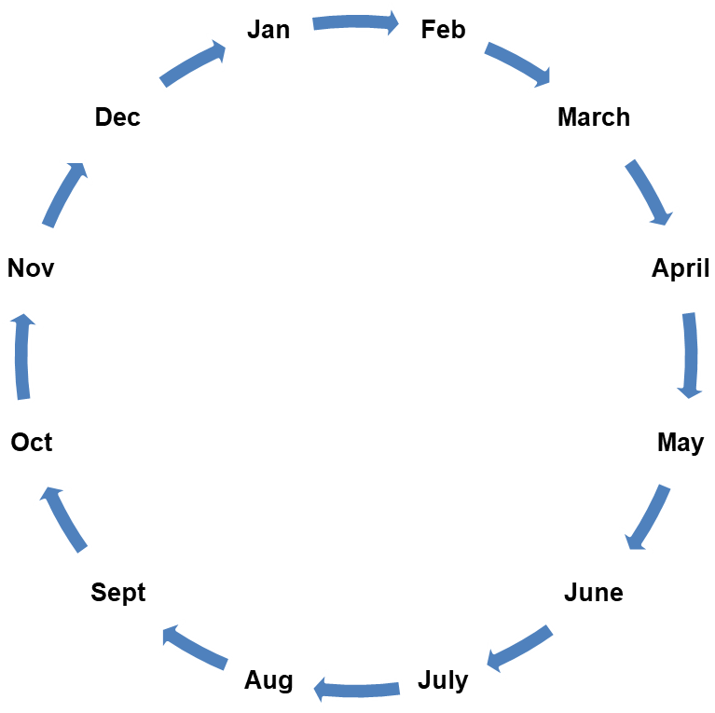

Semester1

Module Evaluation Survey Data

Forecast Progression and Attainment Data, DLHE, EE Report (verbal)

PAR Planning Meeting

EE Reports (written)

Programme Board

Final Progression and Attainment Data, NSS, Enrolment/Tariff Entry Points

LTQG Scrutiny of Draft PAR

University PAR Panel

**Submission of final PAR report to Academic Office**

Submission of UG PAR Report Summary

LTQC receives UG PAR Report Summary

Programme Board

Programme Board

Semester 2

Module Evaluation Survey Data

Data Source

Programme/Department Meeting

University Meeting

Submission Deadline

Annex B

**UNIVERSITY OF ROEHAMPTON**

**Undergraduate Programme Annual Review Report (Collaborative Partners)**

Programme Annual Review (PAR) for taught programmes is the cornerstone of the University’s quality assurance processes. It is an evaluation of a programme(s) following a review of evidence including programme performance data, external examiner reports, student achievement data, destination of leavers from higher education and professional, body reports, where applicable. The PAR should be a reflective process for the programme team(s), providing analysis of past performance and the development and implementation of evidence-based action plans for the future. The programme team must use their own data in order to provide analysis of the performance of the programme. Where there are multiple campuses, comparisons should be made across them.

|  |  |
| --- | --- |
| **Academic Year:** |  |
| **Programme(s):** |  |
| **Academic department:** |  |
| **Collaborative Partner (if applicable)** |  |

|  |
| --- |
| 1. **Programme Summary** [Max. 500 words]   The section should give context to the report, e.g. student numbers, first year of programme, periodic review and identify key points related to the programme from the previous academic year including identifying the strengths and weaknesses. The section should also include any innovative practices to learning, teaching or research, introduced in the previous academic year and the programme team’s assessment of them. |
|  |

|  |  |  |  |
| --- | --- | --- | --- |
| 1. **Key priorities from the previous academic year taken from the previous year’s PAR report** | | | |
| **Priority** | **Actions** | **Progress** | **Completed/ongoing** |
|  |  |  |  |
|  |  |  |  |
|  |  |  |  |
|  |  |  |  |
|  |  |  |  |
|  |  |  |  |

|  |  |  |
| --- | --- | --- |
| 1. **Standards, Quality and Enhancement Plan**   The Standards, Quality and Enhancement Plan should highlight key issues or areas to be addressed across the programme. By using performance indicators, the plan should address the core university issues around teaching excellence, student satisfaction, retention and graduate progression. The programme team should also comment on sector benchmarks for equivalent programmes. For PAR reports covering a programme cluster, actions relating to individual programmes must be flagged where appropriate. | | |
| **Student success**  Non-continuation, academic achievement, analysis by subgroups e.g. BAME [Black and Minority Ethnic students]) | | |
| **Priority** | **Action** | **Responsibility** |
|  |  |  |
|  |  |  |
|  |  |  |

|  |  |  |
| --- | --- | --- |
| **Quality of teaching**  Evidence base to include National Student Survey (NSS) where appropriate, module evaluation surveys, distribution of marks, key data on teaching and learning quality) | | |
| **Priority** | **Action** | **Responsibility** |
|  |  |  |
|  |  |  |
|  |  |  |

|  |  |  |
| --- | --- | --- |
| **Graduate employment and further study**  Destination of leavers from HE (DLHE) | | |
| **Priority** | **Action** | **Responsibility** |
|  |  |  |
|  |  |  |
|  |  |  |

|  |  |  |
| --- | --- | --- |
| **Quality and standards** Evidence base to include External examiner reports, progression and attainment data | | |
| **Priority** | **Action** | **Responsibility** |
|  |  |  |
|  |  |  |
|  |  |  |

|  |  |  |
| --- | --- | --- |
| **Student recruitment**  Evidence base including applications, enrolments, tariff entry | | |
| **Priority** | **Action** | **Responsibility** |
|  |  |  |
|  |  |  |
|  |  |  |

|  |
| --- |
| 1. **Curriculum changes**   This section should summarise modifications and curriculum developments to the programme. Comment on the changes made to the programme which have been implemented in the academic year under consideration, detailing why they were made and if they were successful. This section should also comment on curriculum changes proposed, either as part of modification or periodic review, for the following academic year. |
|  |

|  |  |
| --- | --- |
| **Programme Convener** |  |
| **Programme Convener signature** |  |
| **Date** |  |
| **Head of Department/School (or nominee)** |  |
| **Head of Department/School (or nominee)signature** |  |
| **Date** |  |

**Undergraduate Programme Annual Review (PAR) LTQG Scrutiny Report**

**(Collaborative Provision)**

|  |  |
| --- | --- |
| **Academic Year:** |  |
| **Programme(s):** |  |
| **Academic department:** |  |
| **Collaborative Partner (if applicable)** |  |

|  |
| --- |
| Identify any key issues that should be considered by the University PAR Panel |
|  |

|  |
| --- |
| Where innovative approaches to learning and teaching or research have been identified, examples should be provided |
|  |

Yes No N/A

|  |  |  |  |
| --- | --- | --- | --- |
| Has the programme team fully reported on progress against last year’s priorities? |  |  |  |
| Does the Quality, Standards and Enhancement plan have targeted objectives that have been identified as a result of the review? |  |  |  |
| Has the programme team used and referenced the full range of the evidence base available? (Programme performance data, external examiner reports, student achievement data, National Student Survey (NSS), Destination of Leavers from Higher Education (DLHE) and Professional, Statutory and Regulatory Body (PSRB) reports) |  |  |  |
| Is there evidence that the programme team has addressed the core university issues around teaching excellence in particular student satisfaction, retention and graduate progression? |  |  |  |
| Is there sufficient evidence of the student and graduate voice? |  |  |  |
| Has the programme team referenced sector benchmarks for equivalent programmes? |  |  |  |
| Has the programme team responded to PSRBs requirements where appropriate? |  |  |  |

|  |
| --- |
| Where ‘no’ has been indicated above, additional commentary should be provided |
|  |

**The programme convener is required to make any requested updates as indicated on the scrutiny report, prior to sign off by the LTQG Chair/Scrutineer and submission to the Academic Office**

|  |
| --- |
| LTQG Chair/Scrutineer’s name: |
| LTQG Chair/Scrutineer’s signature: |
| Date: |