Studies currently recruiting participants

There are vacancies for participants in several studies which will help us better understand human cognition and brain function.

Participating in these projects would involve 1-3 hours of your time. In a typical testing session we ask volunteers to perform computer tasks during neuroimaging (e.g. MRI or EEG) and complete questionnaires. This enables us to link psychological processes to activity patterns in the brain.
Our studies take place within the Department or at CUBIC, Royal Holloway, Egham.

Contact one of our researchers for more information or to apply.
Modulating attentional control using connectivity-based functional Magnetic Resonance Imaging (fMRI) neurofeedback  Contact name: Ellie Morgenroth  Email: morgenre@roehampton.ac.uk  Expected recruitment end date: August 2018 | 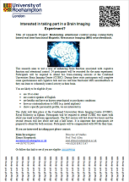  [click image to view/open neurofeedbackinfo.pdf]
The effect of Cannabis of Brain function and anatomy. An fMRI study  Contact name: Yusuf Daniju  Email: danijuy@roehampton.ac.uk  Expected recruitment end date: December 2018 | 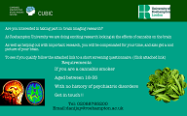  [click image to view/open cannabisMRIinfofullsize.png]
Improving performance with brain stimulation  Contact name: Gergely Bartl  Email: bartlg@roehampton.ac.uk  Text phone: 07555360336  Expected recruitment end date: December 2018 | 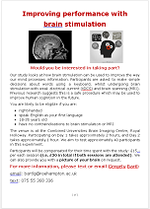  [click image to view/open brainstimMRIinfo.pdf]

