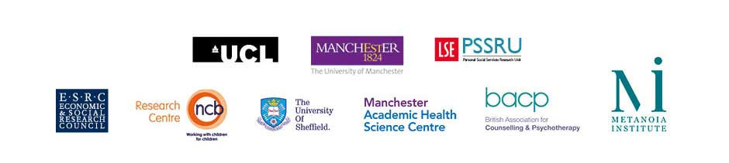

School Counselling Effectiveness Study (ETHOS):
[School logo]
Young Person’s Informed Consent Form (Appendix P6)

Please read through each of the following statements and tick whether you agree or not.

 | YES | NO
I understand what the research is about and that I am being asked to take part in a study of counselling: | [ ] | [ ]
I understand that, if I want to take part and meet the criteria, I will be offered counselling either straight away or in 6-9 months’ time: | [ ] | [ ]
I give permission for my school records to be accessed for research purposes: | [ ] | [ ]
I give permission for the forms I complete to be used for research purposes: | [ ] | [ ]
I give permission to record what I say so the researchers have an accurate record of our conversation: | [ ] | [ ]
I understand that the information I give will not be shared with anyone outside of the research team in a way that they can know who I am: | [ ] | [ ]
I understand that I do not have to take part: | [ ] | [ ]
I understand that I can stop taking part at any time. If I do so, I understand that I can ask for my data to be removed from the study (up to three months after ending my involvement): | [ ] | [ ]
Your name: ..................................................................................................

Date of birth: ..................................................................................................

School: ..................................................................................................

Signature: ..................................................................................................

Today’s date: ..................................................................................................

